STUDY MATERIAL 1 Module -7 ECONOMICS HONOURS SEMESTER –I CC 1-1 2019-20

Consumer Behavior Analysis: Ordinal Utility Approach
Modem economists, particularly Hicks gave ordinal utility concept to analyze consumer behavior.
He has used a tool, called indifference curve, for consumer behavior analysis.
The ordinal utility approach is based on the following assumptions:
i. Rationality:
Implies that a consumer is a rational being and aims at maximizing the total satisfaction given the income and prices of goods and services.
ii. Ordinal Utility:
Assumes that utility is expressible only in ordinal terms. This implies that a consumer is only able to express his/her preference for goods.
iii. Transitivity and Consistency of Choice:
Implies that consumer choices are assumed to be transitive and consistent. The transitivity of choice means that if a consumer prefers A to B and B to C, he/she would prefer A to C. On the other hand, the consistency of choice means that if a consumer prefers A to B in one period, he or she cannot prefer B to A in another period.
iv. Non-satiety:
Implies that a consumer is assumed to be non-satisfied. In other words, it is assumed that consumer does not reach the level of satisfaction by consuming a good and always prefers a large quantity of goods.
v. Diminishing Marginal Rate of Substitution:
Acts as an important concept in indifference curve analysis. Marginal rate of substitution implies the rate at which a consumer is willing to substitute one good (X) for another good (Y), so that the total satisfaction remains the same.
Meaning of Indifference Curve:
Indifference curve is defined as the locus of points on the graph each representing a different combination of two substitute goods, which yield the same utility or level of satisfaction to a consumer. The combinations of goods give equal satisfaction to a consumer.
Therefore, a consumer is indifferent between any two combinations of two goods when it comes to making a choice between them. When these combinations are plotted on the graph, the resulting curve is called indifference curve. This curve is also called as iso-utility curve or equal utility curve.
Let us learn the indifference curve through a schedule.
Table-3 shows the indifference schedule for goods X and Y:
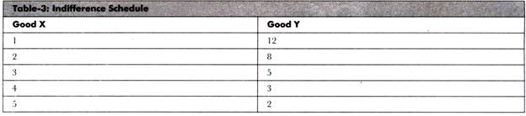
Table-3 depicts that a consumer starts with one unit of good X and 12 units of good Y. For gaining an additional unit of X, he/she sacrifices 4 units of good Y, so that the level of satisfaction remains the same. Similarly, we get the combinations of 3X+ 5Y, 4X+ 3Y, 5X+2Y. The consumer’s satisfaction remain same whichever the combination of goods. This schedule of combinations can be show n graphically on indifference curve. The quantity of good X is measured on X-axis and quantity of good Y is shown on Y- axis.
Figure-6 shows indifference curve:
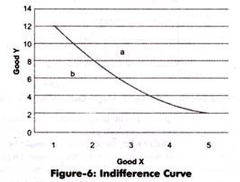
In Figure-6, point b shown below and left of the indifference curve would give less satisfaction and point a above the indifference curve would be more preferred than combinations. A description of consumer’s preferences is represented on indifference map that consists of a set of indifference curves. Indifference map shows the indifference curves ranked in order of preferences of consumers.
Figure-7 shows the indifference m
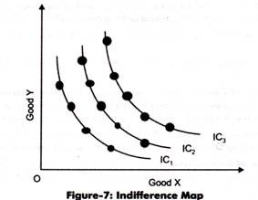
All the combinations on indifference curve IC₁, IC₂, and IC₃ give equal level of satisfaction where IC₃ is more preferred than IC₂ and IC₂ is more preferred than IC₁. A higher indifference curve represents a higher level of satisfaction.
However, the indifference curve does not indicate the exact value of level of satisfaction. This is because indifference curve is based on the concept of ordinal utility, which states that only the qualitative differences in levels of satisfaction can be stated by the consumer.
The properties of indifference curves (as shown in Figure-9) are explained as follows:
i. Indifference curves slopes downward to the right:
Implies that indifference curves have a negative slope. This property is based on the assumption of non-satiation, which refers that a consumer is never satisfied and prefers more of goods to less of it.
Indifference curve being downward sloping implies two things, which are as follows:
a. Two goods can be substituted for each other
b. As quantity of one good increases, the quantity of another good decreases, so that the consumer stays at the same level of satisfaction
This property can be explained through two different situations, which are as follows:
a. If indifference curve is horizontal straight line (parallel to the X-axis)
b. If indifference curve is vertical straight line (parallel to the Y-axis)
c. If indifference curve is upward sloping to the right
If indifference curve is horizontal straight line parallel to X-axis, it implies that good Y would remain constant and there would be change in the quantity of good X.
The horizontal indifference curve is shown in Figure-10:
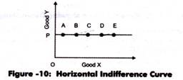
In Figure-10, it can be seen that OP is the fixed amount of good Y and amount of good X is successively larger. It is clear that the consumer always prefers a large quantity of goods. Indifference curve states that at different combinations, consumer is indifferent and his/her total utility remains the same.
However, in this case, a consumer would prefer combination E as it is offering more quantity of X with fixed quantity of Y. The combinations A, B, C, D, and E do not yield same satisfaction to the consumer. Thus, it can be said that the indifference curve cannot be a horizontal straight line.
Similarly, indifference curve cannot be a vertical straight line parallel to Y axis. It would mean that amount of good Y in the combination increases and amount of good X remains the same. As shown in Figure-10, the combinations A, B, C, D, and E do not yield same satisfaction to the consumer, thus, it is proved that indifference curve cannot be a vertical straight line.
Figure-11 shows the vertical indifference curve:
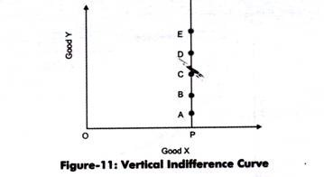
If the indifference curve is upward sloping to the right, it will imply that amount of both the goods offering larger quantities would be preferred. According to indifference curve, the combinations give equal satisfaction; further means that the combination offering large quantities would be equal to combination offering smaller quantities. This would that consumer is irrational. Thus, it is proved that indifference curve cannot slope upward to the right.
Figure-12 shows the upward sloping indifference curve:
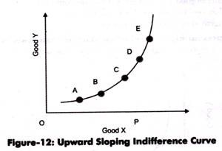
Thus, indifference curve must slope downward to show that when the quantity of one good in a combination increases, the quantity of other good must fall, so that the level of satisfaction remains unchanged.
ii. Indifference curve is convex to the origin:
Implies that MRS decreases and two goods are imperfect substitutes of each other. A convex indifference curve implies that MRS of good X for the good Y falls as more quantity of X is substituted for good Y.
If indifference curve is concave to the origin, it would mean that MRSxy increases as more and more of goods X and Y are consumed. This leads to failure of assumption that MRSxy diminishes. Thus, indifference curve must be convex to the origin.
Figure-13 shows the concave indifference curve:
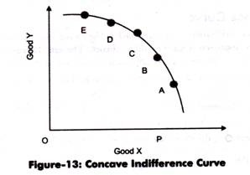
iii. Indifference curve cannot intersect each other:
Implies that only one indifference curve can pass through a point in indifference map.
If two indifference curves intersect each other, two impossible conclusions are achieved, which are as follows:
a. Two equal combinations of goods yield different levels of satisfaction
b. Two different combinations of goods yield same satisfaction
If two indifference curves intersect each other, the assumption of transitivity is contradicted. Let us learn this diagrammatically.
Figure-14 shows the intersection of two indifference curves:
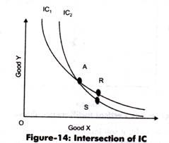
As shown in Figure-14 two indifference curves IC₁ and IC₂ intersect at point C. As all the combinations at indifference curve give equal satisfaction. Therefore, it can be implied from Figure-14 that A=R and A=S. This means that R=S, which is wrong It can be seen that point R gives more of good Y than point S. Thus, the consumer would prefer R to S in terms of satisfaction therefore, it can be concluded that two indifference curves cannot intersect each other. The same reason applies if two indifference curves touch or are tangent to each other at any point.
iv. Higher indifference curve represent higher level of satisfaction than lower one:
Implies that the combinations that lie on higher indifference curve represents higher satisfaction level than the combinations on lower indifference curves.
This can be explained through Figure-15:
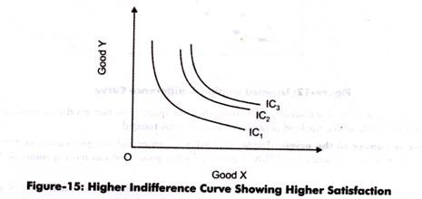
In Figure-15, it can be seen that all combinations on IC₂ give more satisfaction than combinations on IC₁. This is because every combination on IC₂ provides more of both the goods than combination on IC₁.
Criticism of Indifference Curve:
Prof. D.H. Robertson was of the view indifference curve approach is like an old wine in a new bottle and tells nothing new. He further advocates that indifference curve approach is same as utility theory. The only change which Hick has made is in use of words, MRS instead of marginal utility.
The indifference curve approach is criticized on the following grounds:
a. Assumes that there are only two goods in indifference curve approach. This is not true in the real world as a consumer consumes variety of goods.
b. Fails to provide a clear explanation of consumer behavior
c. Provides combinations that are not based on the principles of economics
d. Ignores risk and uncertainty while analyzing the consumer behavior
Concept of Budget Line:
A consumer prefers to reach the highest possible indifference curve on indifference map to attain satisfaction. However, he/she suffers from two constraints, namely, limited income and price of goods. The lack of income is called budgetary constraint.
The budget equation is expressed as:
Px.Qx + Py.Qy = M
Px and Py are the prices of goods X and Y
Qx and Qy are the quantities of goods X and Y
M= money income of the consumer
The budget equation states that the total expenditure cannot exceed the total income.
The quantities can be derived as:
Qx = M/Px-Py/Px. Qy
Qy = M/Py-Px/Py.Qx
When these quantities are plotted on a graph, a budget line is obtained, which is also called price line. The indifference curve shows preferences of combination of two goods where the actual choice of preferences depends on income.
Budget line is the combination of two goods that can be purchased with a given money income and prices of goods. The consumer behavior is well depicted by the budget line. The budget line is drawn as a continuous line that identifies alternatives from which a consumer selects an appropriate combination of goods.
Suppose the income of a consumer is Rs. 60. He/she wants to consume goods X and Y. The price of good X is Rs. 12 and the price of good Y is Rs. 6.
The various preferences of X and Y that can be purchased from the given income and prices are shown in Table-5:
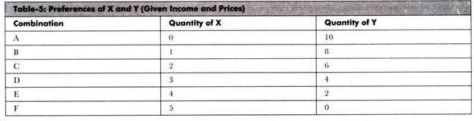
From Table-5, it can be seen in combination A the whole amount of Rs. 60 is spent on purchase of quantity Y. In such a ca.se, the consumer buys 10 units of good Y and nothing is Left for purchasing good X. Similarly, combination F shows that if the consumer spends the entire amount on good X, then he/she is able to purchase 5 units of good X and nothing of good Y. The combinations B to E show the combined quantities of good X and good Y. For instance, in combination B, the consumer would purchase 8 units of good Y and 1 unit of good X.
With the help of preferences, the budget line is drawn, which is shown in Figure-16:
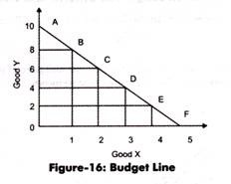
In Figure-16, budget line AF shows various combinations of good X and Y that a consumer can purchase from his or her given budget. The combinations are shown by points A, B, C, D, E, and F that can be purchased with the given budget. If a consumer buys the combination of goods inside the budget line AF, then the total expenditure comes out to be less than the given budget.
Slope of Budget Line:
The slope of a budget line shows how many units of Y are sacrificed to get more units of X.
It can be expressed as:
Slope of the Budget Line = ∆Y/∆X
For instance, from Figure-16, it can be seen that the slope at point B equals to 1 unit of X for 2 units of Y. It implies that 2 units of good X. It should be noted that the slope of budget line is negative. For instance, slope is -2 in case of preference B.
The slope of the budget line (Figure-16) would be given as:
∆Qy/∆Qx = OA/OF
When X = 0, OA = M/Py
When Y = 0, OF = M/Px
Thus, OA/OF = Px/Py
Therefore, it can be said that the slope of the budget line equals to the price ratio of two goods.
Shifts in Budget Line:
The budget line is determined by the income level of consumers and prices of goods in the market. The budget line shifts if there is a change in the income and prices. Let us take the both cases one by one.
Case 1: Change in Income:
Suppose there is a charge in the income of the consumer and the price of the goods remain same. The budget line would shift from the original position. If there is a rise in income, the budget line would shift upward to the right. On the other hand if there is a fell in income, the budget line would shift downward to the left.
Figure-17 shows a shift in budget line due to change in income:
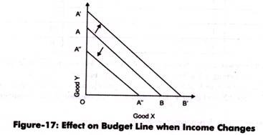
From Figure-17, it can be seen that a rise in income shifts the budget line from AB to A’B’ and a fall in income shifts the budget line from AB to A”B”.
Case 2: Change in Prices:
Suppose there is a change in the price of a good, say good X, and the income and price of good Y are constant. If there is a fall in the price of good X, then the consumer can buy more of good X with the same income.
Figure-18 shows the shift in the budget line due to change in the price of good X:
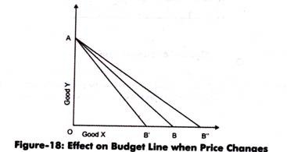
As shown in Figure-18, when the price of good X falls, this would make the budget line too move flatter and rightward from “AB to AB”. In case, the price of good X increases, the budget line shifts to the left that is from AB to AB’.
Consumer’s Equilibrium through Indifference Curve and Budget Line:
Consumer’s equilibrium is the point at which consumer attains maximum satisfaction. A consumer is said to be in equilibrium when the budget line touches indifference curve, with given price and income.
The consumer’s equilibrium through indifference curve and budget line is shown in Figure-19:
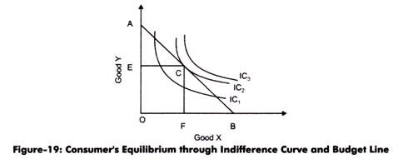
In Figure-19, there are three indifference curves IC1, IC2 and IC3. The budget line AB is tangent to IC2 at point C. At this level, a consumer attains maximum satisfaction level at OE units of good Y and OF units of good X. This is the first condition for the consumer to be in equilibrium that indifference curve should touch the budget line. The second condition is that the slope of budget line should be equal to the slope of indifference curve.
Slope of budget line =Px/Py
Slope of indifference curve= ∆Y/∆X = MRSxy
Thus, Px/Py = MRSxy

Price Consumption Curve: With Diagram | Indifference Curve
We will now explain how the consumer reacts to charges in the price of a good, his money income, tastes and prices of other goods remaining the same. Price effect shows this reaction of the consumer and measures the full effect of the change in the price of a good on the quantity purchased since no compensating variation in income is made in this case.
When, the price of good charges, the consumer would be either better off or worse off than before, depending upon whether the price falls or rises. In other words, as a result of change in price of a good, his equilibrium position would lie at a higher indifference curve in case of the fall in price and at a lower indifference curve in case of the rise in price.
Price effect is shown in Fig. 8.31. With given prices of goods X and Y, and a given money income as represented by the budget line PL₁, the consumer is in equilibrium at Q on indifference curve C₁. In this equilibrium position at Q, he is buying OM₁ of X and ON₁ of Y. Let price of good id X fall, price of Y and his money income remaining unchanged.
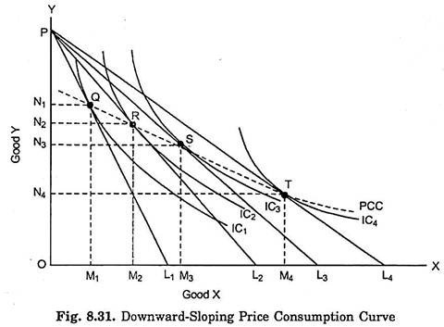
As a result of this price change, budget line shifts to the position PL₂. The consumer is now in equilibrium at R on a higher indifference curve IC₂ and is buying OM₂ of X and ON₂ of Y. He has thus become better off, that is, his level of satisfaction has increased as a consequence of the fall in the price of good X. Suppose that price of X further falls so that PL₃ is now the relevant price line.
With budget line PL₃ the consumer is in equilibrium at S on indifference curve IC₃ where he has OM₃ of X and ON₃ of Y. If the price of good X falls still further so that budget line now takes the position of PL₄, the consumer now attains equilibrium at T on indifference curve IC₄ and has OM₄ of X and ON₄ of Y.
When all the equilibrium points such as Q, R, S, and T are joined together, we get what is called Price Consumption Curve (PCC). Price consumption curve traces out the price effect. It shows how the changes in price of good X will affect the consumer’s purchases of X, price of Y, his tastes and money income remaining unaltered.
In Fig. 8.31 price consumption curve (PCC) is sloping downward. Downward sloping price consumption curve for good X means that as the price of good X falls, the consumer purchases a larger quantity of good X and a smaller quantity of good Y. This is quite evident from Fig. 8.31.
In elasticity of demand, we obtain downward-sloping price consumption curve for good X when demand for it is elastic (i.e., price elasticity is greater than one). But downward sloping is one possible shape of price consumption curve. Price consumption curve can have other shapes also.
In Fig. 8.32 upward-sloping price consumption curve is shown. Upward-sloping price consumption curve for X means that when the price of good X falls, the quantity demanded of both goods X and Y rises. We obtain the upward-sloping price consumption curve for good X when the demand for good is inelastic, (i.e., price elasticity is less than one).
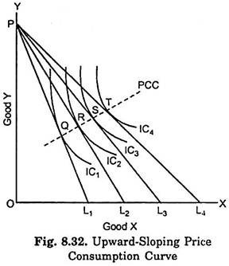
Price consumption curve can also have a backward-sloping shape, which is depicted in Fig. 8.33. Backward-sloping price consumption curve for good X indicates that when price of X falls, after a point smaller quantity of it is demanded or purchased. This is true in case of exceptional type of goods called Giffen Goods.
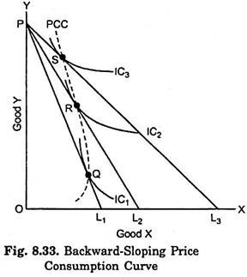
Price consumption curve for a good can take horizontal shape too. It means that when the price of the good X declines, its quantity purchased rises proportionately but quantity purchased of Y remains the same. Horizontal price consumption curve is shown in Fig. 8.34. We obtain horizontal price consumption curve of good X when the price elasticity of demand for good X is equal to unity.
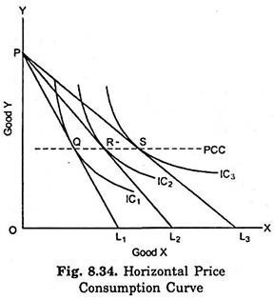
But it is rarely found that price consumption curve slopes downward throughout or slopes upward throughout or slopes backward throughout. More generally, price consumption curve has different slopes at different price ranges. At higher price levels it generally slopes downward, and it may then have a horizontal shape for some price ranges but ultimately it will be sloping upward. For some price ranges it can be backward sloping as in case of Giffen goods. A price consumption curve which has different shapes or slopes at different price ranges is drawn in Fig. 8.35.

Income Effect: Income Consumption Curve
With a given money income to spend on goods, given prices of the two goods and given an indifference map (which portrays given tastes and preferences of the consumers), the consumer will be in equilibrium at a point in an indifference map.
We are interested in knowing how the consumer will react in regard to his purchases of the goods when his money income changes, prices of the goods and his tastes and preferences remaining unchanged.
Income effect shows this reaction of the consumer. Thus, the income effect means the change in consumer’s purchases of the goods as a result of a change in his money income. Income effect is illustrated in Fig. 8.28.
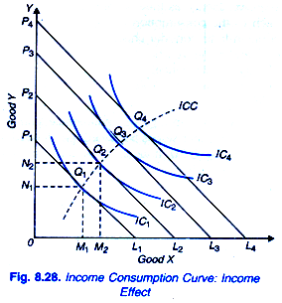
With given prices and a given money income as indicated by the budget line P₁L₁ the consumer is initially in equilibrium at point Q₁ on the indifference curve IC₁ and is having OM₁ of X and ON₁ of Y. Now suppose that income of the consumer increases. With his increased income, he would be able to purchase larger quantities of both the goods.
As a result, budget line will shift upward and will be parallel to the original budget line P₁L₁. Let us assume that the consumer’s money income increases by such an amount that the new budget line is P₂L₂ (consumer’s income has increased by L₁L₂ in terms of X or P₁P₂ in terms of Y). With budget line P₂L₂, the consumer is in equilibrium at point Q₂ on indifference curves IC₂ and is buying OM₂ of X and ON₂ of Y.
In case of inferior goods, indifference map would be such as to yield income consumption curve which either slopes backward (i.e., toward the left) as in Fig. 8.29, or downward to the right as in Fig. 8.30. It would be noticed from these two figures that income effect becomes negative only after a point. It signifies that only at higher ranges of income, some goods become inferior goods and up to a point their consumption behaves like those of normal goods. In Fig. 8.29 income consumption curve (ICC) slopes backward i.e., bends toward the Y-axis.
This shows good X to be an inferior good, since beyond point Q₂, income effect is negative for good X and as a result its quantity demanded falls as income increases. In Fig.8.30 income consumption curve (ICC) slopes downward to the right beyond point Q₂ bends towards the X-axis.
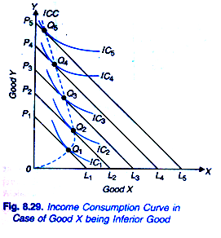
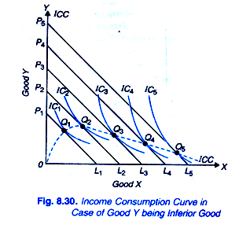This signifies that good Y is an inferior good because beyond point Q₂, income effect is negative for good Y and as a result its quantity demanded falls as income increases. It follows from above that the income consumption curve can have various possible shapes.
But normal goods can be either necessities or luxuries depending upon whether the quantities purchased of the goods by the consumers increase less than or more than proportionately to the increases in income. If the quantity purchased of a commodity rises less than proportionately to the increases in consumer’s income, the commodity is known as a necessity.
On the other hand, if the quantity purchased of a commodity increases more than proportionately to the increases in income, it is called a luxury. In Fig. 8.31, the slope of income consumption curve ICC₁ is increasing which implies that the quantity purchased of the commodity X increases less than proportionately to the increases in consumer’s income.
Therefore, in this case of ICC₁, good X is a necessity and good Vis luxury. On the other hand, the slope of income consumption curve ICC₃ is decreasing which implies that the quantity purchased of good X increases more than proportionately to increases in income and therefore in this case good X is luxury and good Vis necessity. It will be seen from Fig. 8.31 that the income consumption curve ICC₂ is a linear curve passing through the origin which implies that the increases in the quantities purchased of both the goods are rising in proportion to the increase in income and therefore neither good is a luxury or a necessity.
If income effect is positive for both the goods X and Y, the income consumption curve will slope upward to the right as in Fig. 8.28 given earlier. But upward-sloping income consumption curves to the right for various goods may be of different slopes as shown in Fig. 8.31 in which income consumption curves, with varying slopes, are all sloping upward and therefore indicate both goods to be normal goods having positive income effect.

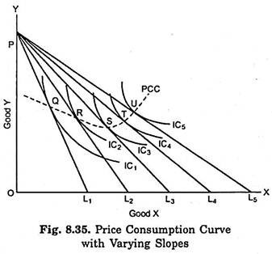

Income Effect, Substitution Effect and Price Effect on Goods

The Price Effect:
The price effect indicates the way the consumer’s purchases of good X change, when its price changes, A given his income, tastes and preferences and the price of good Y. This is shown in Figure 12.18. Suppose the price of X falls. The budget line PQ will extend further out to the right as PQ₁, showing that the consumer will buy more X than before as X has become cheaper. The budget line PQ₂ shows a further fall in the price of X. Any rise in the price of X will be represented by the budget line being drawn inward to the left of the original budget line towards the origin.
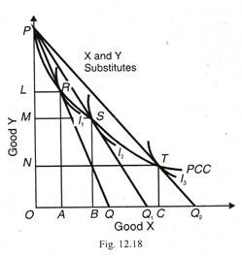
If we regard PQ₂, as the original budget line, a two time rise in the price of X will lead to the shifting of the budget line to PQ₁, and PQ₂. Each of the budget lines fanning out from P is a tangent to an indifference curve I₁, I₂, and I₃ at R, S and T respectively. The curve PCC connecting the locus of these equilibrium points is called the price- consumption curve. The price-consumption curve indicates the price effect of a change in the price of X on the consumer’s purchases of the two goods X and Y, given his income, tastes, preferences and the price of good Y.

