STUDY MATERIAL 1 Module -9 ECONOMICS HONOURS SEMESTER –I CC 1-1 2019-20

Mathematics | Limits, Continuity and Differentiability

1. Limits –
For a function the limit of the function at a point is the value the function achieves at a point which is very close to .
Formally,
Let be a function defined over some interval containing , except that it
may not be defined at that point.
We say that, if there is a number for every number such that
whenever
The concept of limit is explained graphically in the following image –
The concept of limit is explained graphically in the following image –
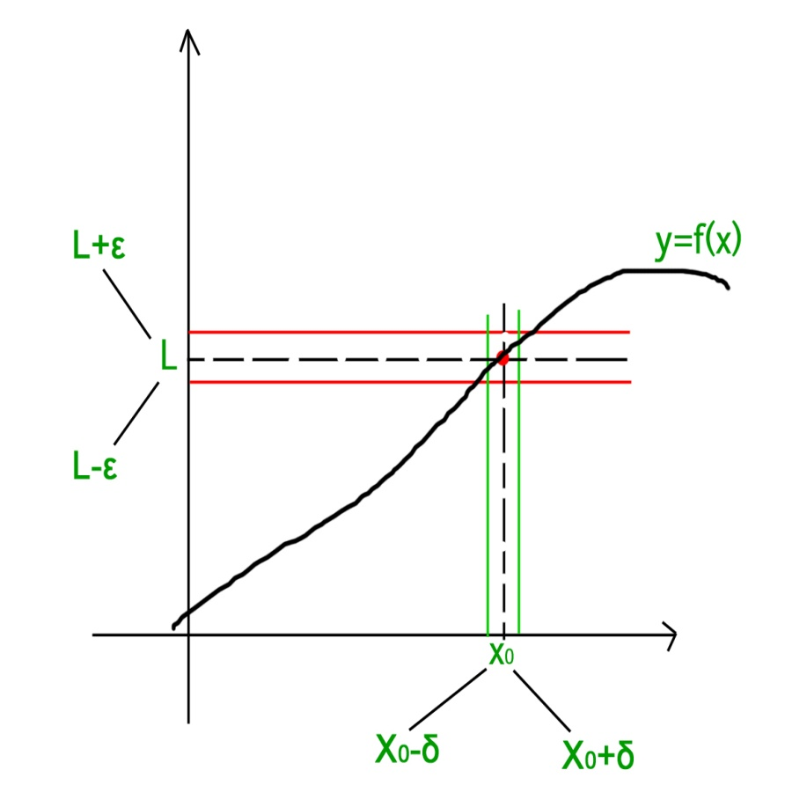
As is clear from the above figure, the limit can be approached from either sides of the number line i.e. the limit can be defined in terms of a number less that or in terms of a number greater than . Using this criteria there are two types of limits –
Left Hand Limit – If the limit is defined in terms of a number which is less than then the limit is said to be the left hand limit. It is denoted as which is equivalent to where and .
Right Hand Limit – If the limit is defined in terms of a number which is greater than then the limit is said to be the right hand limit. It is denoted as which is equivalent to where and .

FUNCTIONS, LIMITS, AND CONTINUITY NOTESMPP MATH CAMP 20171.FunctionsRecommended Reading:Section 1.1 ofApplied Calculusby Hoffman and Bradley.Definition.Afunctionis a rule that assigns every object in a setXa new object in a setY.There are many ways to think of functions: a machine that eats a number and spits out another number,a graph, or a mapping betweenXandY. They are useful in social sciences because the value/quantityof one object often depends on the value/quantity of another. A function can describe that relationshipmathematically.Example.The mapf(x) =x2is a function fromRtoR. It takes in real numbers as its input, and outputstheir square. Notice that the output is asingle valuefor every specific input.A function does not have to be defined by a single rule as in the previous example.Piece-wise functionsare defined by different rules on different intervals.Example.The piece-wise mapf(x) =1ifx >0,−1ifx <10isnota function, because it does not a assign a single value tox= 2 (or any other value ofxbetween 0 and10).A function can even be defined only at specific points.Example.Suppose you have a (completely fictional) data set that looks at a school’s budget and averagetest scores.Annual School Budget in USDAverage ACT Score656,24724700,25525923,456261
2MPP MATH CAMP 2017This gives you a function fromX={budget amounts}toY={ACT scores}. By analyzing this function,you may be able to determine if there is a relationship between budget and average test score.Definition.Iffis a function fromXtoY, thenXis called therangeoff. Thedomainoffis the set ofelementsyinYsuch thatf(x) =yfor somexinX.Our domains and ranges will usually be intervals on the real number line. These are denoted as follows:(a,b) ={x∈R|a < x < b}[a,b] ={x∈R|a≤x≤b}[a,b) ={x∈R|a≤x < b}(a,b] ={x∈R|a < x≤b}If we want, we can use +∞or−∞in place ofaorbto denote an infinite interval.Sometimes, the domain of a function is not made explicitly clear. In this case, theimplicit domainis theset of real numbers for which the function is defined.Example.Find the implicit domain of the functionf(x) =√x−1.Since we can’t take the square root of a negative number, this is only defined whenx−1≥0. Equivalently,we needx≥1. So the implicit domain offis [1,+∞), and its range is [0,+∞)Functions can be put together in several ways. We can add and multiply functions, for example:h(x) =f(x) +g(x), k(x) =f(x)·g(x), j(x) =f(x)g(x).Notice that the range ofh,k,andjwill depend on the ranges and domains offandg.Example.Letf(x) =√x−1 andg(x) = (x+ 1)2+ 10.Find the (implicit) domain and range ofh(x),k(x),andj(x).DomainRangef(x)[1,+∞)[0,+∞)g(x)R[10,+∞)h(x)[1,+∞) [10,+∞)k(x)[1,+∞)[0,+∞)j(x)[1,+∞)[0,+∞)We can alsocomposefunctions:h(x) =f(g(x)) =f◦g(x).We have already seen this in action. Iff(x) =√xandg(x) =x−1, thenf(g(x)) =√x−1. We can also dothis with more exciting functions. As before, the domain and range of a composition of functions dependson the composite functions.
FUNCTIONS, LIMITS, AND CONTINUITY NOTES3Example.Letf(x) =√x−1 andg(x) = (x+ 1)2+ 10.Ifh(x) =f(g(x)) andk(x) =g(f(x)), then find thedomain and range ofh(x) andk(x).DomainRangef(x)[1,+∞)[0,+∞)g(x)R[10,+∞)h(x)R[3,+∞)k(x)[1,+∞) [11,+∞)Example.Common functions with their domains and ranges:Name of FunctionDenotedDomainRangeIdentityf(x) =xRRConstantf(x) =cRRPolynomialsf(x) =anxn+an−1xn−1+···+a1x+a0Rdepends!Rational Functionsf(x) =P(x)Q(x)where,P,Qare polynomialsdepends!depends!Absolute Valuef(x) =|x|=xifx≥0,−xifx≤0R[0,+∞)Exponentialf(x) =axR(0,+∞)Logarithmf(x) = loga(x)(0,+∞)R
4MPP MATH CAMP 2017Review: Exponentials and LogsFor any real numberaand natural numbern, we definean=aa···a, the product ofncopies ofa, and we definea0= 1. We definea−nso thata−n·an= 1. In other words,a−n=1an. We definea1/nso that (a1/n)n= 1. In other words,a1/n=n√a.Then for irrationalx, we defineaxso thatf(x) =axis continuous.We define loga(b) to be the numberxsuch thatax=b. In other words,aloga(b)=a.Notice that ifa(x) =ax, then loga◦expa(x) = expa◦loga(x) =x, whenever these aredefined.Rules of ExponentsFora >0 and anyx,y∈R, we have•ax·ay=ax+y•ax/ay=ax−y•(ax)y=axy.Rules of LogarithmsFora,b,x,y >0 andb6= 1, we have•loga(xy) = loga(x) + loga(y)•loga(x/y) = loga(x)−loga(y)•loga(xn) =nloga(x)•loga(x)logb(x)logb(a).
FUNCTIONS, LIMITS, AND CONTINUITY NOTES52.LimitsRecommended Reading:Sections 1.5-1.6 of “Applied Calculus” by Hoffman and Bradley.The difference between algebra and calculus comes down tolimits- the analysis of the behavior of afunction as it approaches some point (which may or may not be in the domain of the function!). This comesup in the real world all the time: any time a model uses “ideal” conditions, we are looking at a limit.The key idea in limits is to get steadily closer approximations, and look at the pattern made by theseapproximations. The first example of this principle in action comes from the Greeks, who approximated thearea of a circle using successively smaller triangles. However, the method wasn’t formalized until the 19thcentury (actuallyafterthe invention/discovery of Calculus by Newton and Leibniz).Definition.A functionfhas alimitLataif for all >0 there exists aδ >0 such that 0<|x−a|< δimplies that|f(x)−L|< . We write this aslimx→af(x) =L.Example.The following simple functions have limits (everywhere). We can prove the following statementsfrom the definition.•Letf(x) = 0. Then the limit offat 0 is 0.•Letg(x) =x. Then the limit offat 1 is 1.But we can also use some simple properties of limits to make some calculations easier.Theorem 2.1.(Algebraic Properties of Limits) Iflimx→af(x) =Fandlimx→ag(x) =G, then(1) limx→a(f(x) +g(x)) =F+G,(2) limx→a(f(x)−g(x)) =F−G,(3) limx→a(f(x)·g(x)) =F·G,(4) limx→af(x)g(x)=FG, ifG6= 0,(5) limx→akf(x) =kFfor anyk∈R, and(6) limx→a(f(x))p=Fpfor anyp∈R.Example.We can prove the following using the algebraic properties of limits.•limx→0x2+ 3 = 3•limx→2x−4x2−5x+6•limx→1√x−1x−1
6MPP MATH CAMP 2017Sometimes, we only know (or care) about half of our function. In these cases, we may want to considerone-sidedlimits.Definition.A functionfhas aright- (left-)handed limitLataif for all >0, there exists aδ >0 suchthat 0< x−a < δ(0< a−x < δ) implies|f(x)−L|≤.We denote the right- and left- handed limits bylimx→a+f(x) =Landlimx→a−f(x) =L,respectively.Note that a function has a limitLataif and only if both the right- and left-handed limits offataareL.Example.Suppose we have a piecewise functionf(x) =xifx >10ifx≤1.Then limx→1+= 1, limx→1−= 0, and limx→1does not exist.In addition to non-existence, some functions can have a limit of±∞.Example.Iff(x) =1x, thenfis not defined at 0. But limx→0+1x= +∞.Example.A special case of one-sided limits is taking a limit “at infinity.”•limx→+∞0 = 0•limx→+∞1x= 0•Letf(x) =1if [x] is even,−1if [x] is oddThen limx→+∞f(x) does not exist.
FUNCTIONS, LIMITS, AND CONTINUITY NOTES73.ContinuityRecommended Reading:Section 1.6 of “Applied Calculus” by Hoffman and Bradley.Intuitively, a function is continuous if you can draw its graph without picking up your pencil. If you wantto be rigorous, this is a useless definition. However, it gives a good first approximation.Definition.A functionfiscontinuousatciflimx→cf(x) =f(c).Note that for a function to be continuous at a pointc, limx→cf(x) andf(c) must exist! A function whichis not continuous at a pointchas adiscontinuityatc. There are different types of discontinuity.Example.The following functions are discontinuous at 0, in different ways.(1)f(x) =1x(2)f(x) =2x+ 1ifx6= 0,2ifx= 0(3)f(x) =2x+ 1ifx >0,2ifx≤0(4)f(x) =1xifx6= 0,xifx= 0(5)f(x) =1xifx >0,xifx≤0Notice, however, that a function may have more than one discontinuity. In fact, a function can haveinfinitely many discontinuities!Definition.A function is continuous on an open interval (a,b) if it is continuous atcfor allc∈(a,b). Afunction is continuous on a closed interval [a,b] if, additionally, the right- and left-handed limits exist ataandb, respectively, and are equal tof(a) andf(b), respectively.Example.Consider the functionf(x) =1xif 0< x <1xif 1≤x <20if 2≤x.
8MPP MATH CAMP 2017This is continuous on (0,2) and on [2,+∞). But it is discontinuous at 2.The functionsf(x) =axandf(x) = loga(x) are continuous everywhere on their domains.Example.The functionf(x) = loga(x2−1) is continuous on (1,+∞). It is not continuous on [1,+∞)becausef(1) is not defined.

Section 4-10 : L'Hospital's Rule and Indeterminate Forms
Back in the chapter on Limits we saw methods for dealing with the following limits.
limx→4x2−16x−4limx→∞4x2−5x1−3x2
In the first limit if we plugged in x=4
we would get 0/0 and in the second limit if we “plugged” in infinity we would get ∞/−∞ (recall that as x
goes to infinity a polynomial will behave in the same fashion that its largest power behaves). Both of these are called indeterminate forms. In both of these cases there are competing interests or rules and it’s not clear which will win out.
In the case of 0/0 we typically think of a fraction that has a numerator of zero as being zero. However, we also tend to think of fractions in which the denominator is going to zero, in the limit, as infinity or might not exist at all. Likewise, we tend to think of a fraction in which the numerator and denominator are the same as one. So, which will win out? Or will neither win out and they all “cancel out” and the limit will reach some other value?
In the case of ∞/−∞
we have a similar set of problems. If the numerator of a fraction is going to infinity we tend to think of the whole fraction going to infinity. Also, if the denominator is going to infinity, in the limit, we tend to think of the fraction as going to zero. We also have the case of a fraction in which the numerator and denominator are the same (ignoring the minus sign) and so we might get -1. Again, it’s not clear which of these will win out, if any of them will win out.
With the second limit there is the further problem that infinity isn’t really a number and so we really shouldn’t even treat it like a number. Much of the time it simply won’t behave as we would expect it to if it was a number. To look a little more into this, check out the Types of Infinity section in the Extras chapter at the end of this document.
This is the problem with indeterminate forms. It’s just not clear what is happening in the limit. There are other types of indeterminate forms as well. Some other types are,
(0)(±∞)1∞00∞0∞−∞
These all have competing interests or rules that tell us what should happen and it’s just not clear which, if any, of the interests or rules will win out. The topic of this section is how to deal with these kinds of limits.
As already pointed out we do know how to deal with some kinds of indeterminate forms already. For the two limits above we work them as follows.
limx→4x2−16x−4=limx→4(x+4)=8 limx→∞4x2−5x1−3x2=limx→∞4−5x1x2−3=−43
In the first case we simply factored, canceled and took the limit and in the second case we factored out an x2
from both the numerator and the denominator and took the limit. Notice as well that none of the competing interests or rules in these cases won out! That is often the case.
So, we can deal with some of these. However, what about the following two limits.
limx→0sinxxlimx→∞exx2
This first is a 0/0 indeterminate form, but we can’t factor this one. The second is an ∞/∞
indeterminate form, but we can’t just factor an x2
out of the numerator. So, nothing that we’ve got in our bag of tricks will work with these two limits.
This is where the subject of this section comes into play.

L’Hospital’s Rule
Suppose that we have one of the following cases,
limx→af(x)g(x)=00ORlimx→af(x)g(x)=±∞±∞
where a
can be any real number, infinity or negative infinity. In these cases we have,
limx→af(x)g(x)=limx→af′(x)g′(x)
So, L’Hospital’s Rule tells us that if we have an indeterminate form 0/0 or ∞/∞
all we need to do is differentiate the numerator and differentiate the denominator and then take the limit.
Before proceeding with examples let me address the spelling of “L’Hospital”. The more modern spelling is “L’Hôpital”. However, when I first learned Calculus my teacher used the spelling that I use in these notes and the first text book that I taught Calculus out of also used the spelling that I use here.
Also, as noted on the Wikipedia page for L’Hospital's Rule,
“In the 17th and 18th centuries, the name was commonly spelled "l'Hospital", and he himself spelled his name that way. However, French spellings have been altered: the silent 's' has been removed and replaced with the circumflex over the preceding vowel. The former spelling is still used in English where there is no circumflex.”
So, the spelling that I’ve used here is an acceptable spelling of his name, albeit not the modern spelling, and because I’m used to spelling it as “L’Hospital” that is the spelling that I’m going to use in these notes.
Let’s work some examples.

