STUDY MATERIAL 1 Module -13 ECONOMICS GENERAL GE -1 SEMESTER –I 2019-20
Understanding Consumer’s Equilibrium by Indifference Curve Analysis!
Consumer equilibrium refers to a situation, in which a consumer derives maximum satisfaction, with no intention to change it and subject to given prices and his given income. The point of maximum satisfaction is achieved by studying indifference map and budget line together.
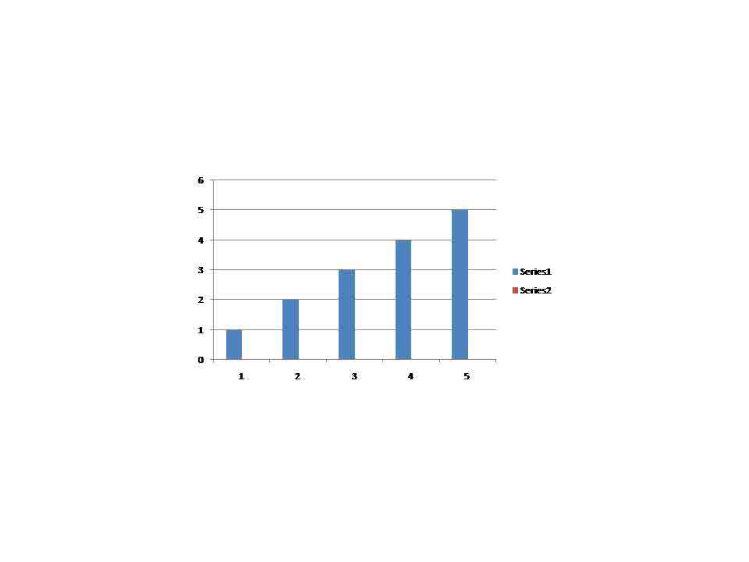
On an indifference map, higher indifference curve represents a higher level of satisfaction than any lower indifference curve. So, a consumer always tries to remain at the highest possible indifference curve, subject to his budget constraint.

Conditions of Consumer’s Equilibrium:
The consumer’s equilibrium under the indifference curve theory must meet the following two conditions:
(i) MRS_{XY} = Ratio of prices or P_{X}/P_{Y}

Let the two goods be X and Y. The first condition for consumer’s equilibrium is that
MRS_{XY} = P_{X}/P_{Y}
a. If MRS_{XY} > P_{X}/P_{Y}, it means that the consumer is willing to pay more for X than the price prevailing in the market. As a result, the consumer buys more of X. As a result, MRS falls till it becomes equal to the ratio of prices and the equilibrium is established.
b. If MRS_{XY} < P_{X}/P_{Y}, it means that the consumer is willing to pay less for X than the price prevailing in the market. It induces the consumer to buys less of X and more of Y. As a result, MRS rises till it becomes equal to the ratio of prices and the equilibrium is establi
(ii) MRS continuously falls:
The second condition for consumer’s equilibrium is that MRS must be diminishing at the point of equilibrium, i.e. the indifference curve must be convex to the origin at the point of equilibrium. Unless MRS continuously falls, the equilibrium cannot be established.
Thus, both the conditions need to be fulfilled for a consumer to be in equilibrium.
Let us now understand this with the help of a diagram:

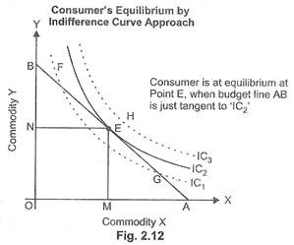
In Fig. 2.12, IC₁, IC₂ and IC₃ are the three indifference curves and AB is the budget line. With the constraint of budget line, the highest indifference curve, which a consumer can reach, is IC₂. The budget line is tangent to indifference curve IC₂ at point ‘E’. This is the point of consumer equilibrium, where the consumer purchases OM quantity of commodity ‘X’ and ON quantity of commodity ‘Y.
All other points on the budget line to the left or right of point ‘E’ will lie on lower indifference curves and thus indicate a lower level of satisfaction. As budget line can be tangent to one and only one indifference curve, consumer maximizes his satisfaction at point E, when both the conditions of consumer’s equilibrium are satisfied:
(i) MRS = Ratio of prices or P_{X}/P_{Y}:
ADVERTISEMENTS:
At tangency point E, the absolute value of the slope of the indifference curve (MRS between X and Y) and that of the budget line (price ratio) are same. Equilibrium cannot be established at any other point as MRS_{XY} > P_{X}/P_{Y} at all points to the left of point E and MRS_{XY} < P_{X}/P_{Y} at all points to the right of point E. So, equilibrium is established at point E, when MRS_{XY} = P_{X}/P_{Y}.
(ii) MRS continuously falls:
The second condition is also satisfied at point E as MRS is diminishing at point E, i.e. IC₂ is convex to the origin at point E.

Income Effect, Substitution Effect and Price Effect!
In the above analysis of the consumer’s equilibrium it was assumed that the income of the consumer remains constant, given the prices of the goods X and Y. Given the tastes and preferences of the consumer and the prices of the two goods, if the income of the consumer changes, the effect it will have on his purchases is known as the income Effect.
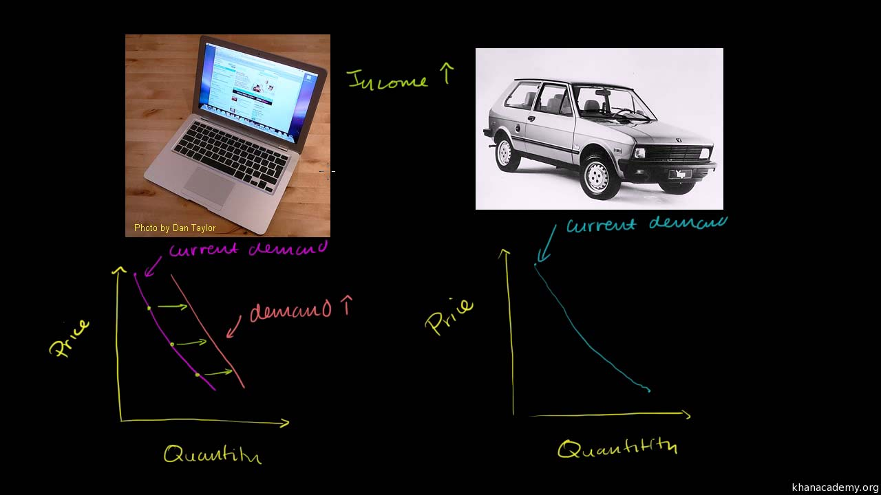

If the income of the consumer increases his budget line will shift upward to the right, parallel to the original budget line. On the contrary, a fall in his income will shift the budget line inward to the left. The budget lines are parallel to each other because relative prices remain unchanged.
In Figure 12.14 when the budget line is PQ, the equilibrium point is R where it touches the indifference curve I₁. If now the income of the consumer increases, PQ will move to the right as the budget line P₁, I₁, and the new equilibrium point is S where it touches the indifference curve I₂. As income increases further, PQ becomes the budget line with T as its equilibrium point.
The locus of these equilibrium points R, S and T traces out a curve which is called the income-consumption curve (ICC). The ICC curve shows the income effect of changes in consumer’s income on the purchases of the two goods, given their relative prices.

Normally, when the income of the consumer increases, he purchases larger quantities of two goods. In Figure 12.14 he buys RA of Y and OA of X at the equilibrium point R on the budget line PQ. As his income increases, he buys SB of Y and OB of X at the equilibrium point S on P₁, Q₁, budget line and still more of the two goods TC of Y and ОС of X, on the budget line P₂Q₂. Usually, the income consumption curve slopes upwards to the right as shown in Figure 12.14.
But an income-consumption curve can have any shape provided it does not intersect an indifference curve more than once. We can have five types of income consumption curves. The first type is explained above in Figure 12.14 where the ICC curve has a positive slope throughout its range. Here the income effect is also positive and both X and Y are normal goods.
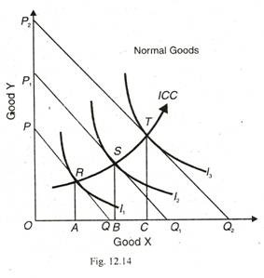
The second type of ICC curve may have a positive slope in the beginning but become and stay horizontal beyond a certain point when the income of the consumer continues to increase. In Figure 12.15 (A) the ICC curve slopes upwards with the increase in income upto the equilibrium point R at the budget line P₁Q₁ on the indifference cure I₂. Beyond this point it becomes horizontal which signifies that the consumer has reached the saturation point with regard to the consumption of good Y. He buys the same amount of Y (RA) as before despite further increases in his income. It often happens in the case of a necessity (like salt) whose demand remains the same even when the income of the consumer continues to increase further. Here Y is a necessity.

Figure 12.15 (B) shows a vertical income consumption curve when the consumption of good X reaches the saturation level R on the part of the consumer. He has no inclination to increase its purchases despite further increases in his income. He continues to purchase OA of it even at higher income levels. Thus X is a necessity here.
The last two types of income consumption curves relate to inferior goods. The demand of inferior goods falls, when the income of the consumer increases beyond a certain level, and he replaces them by superior substitutes. He may replace coarse grains by wheat or rice, and coarse cloth by a fine variety. In Figure 12.15 (C), good Y is inferior and X is a superior or luxury good.
Upto point R the ICC curve has- a positive slope and beyond that it is negatively inclined. The consumer’s purchases of Y fall with the increase in his income. Similarly in Figure 12.15 (D), good X is shown as inferior and Y is a superior good beyond the equilibrium point R when the ICC curve turns back upon itself. In both these cases the income effect is negative beyond point R on the income-consumption curve ICC.
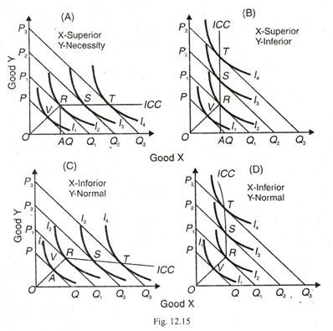
The different types of income-consumption curves are also shown in Figure 12.16 where: (1) ICC₁ Alternative Method, has a positive slope and relates to normal goods; (2) IСС₂ is horizontal from point A, X is a normal good while Y is a necessity of which the consumer does not want to have more than the usual quantity as his income increases further: (3) IСС₃ is vertical from A, К is a normal good here and X is satiated necessity; (4) ICC₄ is negatively inclined downwards, Y becomes an inferior good form A onwards and X is a superior good; and (5) ICC₅ shows X as an inferior good.
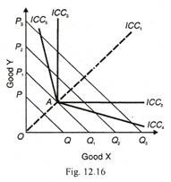

The Substitution Effect:
The substitution effect relates to the change in the quantity demanded resulting from a change in the price of good due to the substitution of relatively cheaper good for a dearer one, while keeping the price of the other good and real income and tastes of the consumer as constant. Prof. Hicks has explained the substitution effect independent of the income effect through compensating variation in income. “The substitution effect is the increase in the quantity bought as the price of the commodity falls, after adjusting income so as to keep the real purchasing power of the consumer the same as before. This adjustment in income is called compensating variations and is shown graphically by a parallel shift of the new budget line until it become tangent to the initial indifference curve.”
Thus on the basis of the methods of compensating variation, the substitution effect measure the effect of change in the relative price of a good with real income constant. The increase in the real income of the consumer as a result of fall in the price of, say good X, is so withdrawn that he is neither better off nor worse off than before.

The substitution effect is explained in Figure 12.17 where the original budget line is PQ with equilibrium at point R on the indifference curve I₁. At R, the consumer is buying OB of X and BR of Y. Suppose the price of X falls so that his new budget line is PQ₁. With the fall in the price of X, the real income of the consumer increases. To make the compensating variation in income or to keep the consumer’s real income constant, take away the increase in his income equal to PM of good Y or Q₁N of good X so that his budget line PQ₁ shifts to the left as MN and is parallel to it.
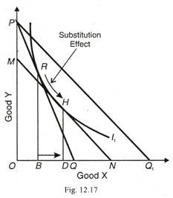
At the same time, MN is tangent to the original indifference curve l₁ but at point H where the consumer buys OD of X and DH of Y. Thus PM of Y or Q₁N of X represents the compensating variation in income, as shown by the line MN being tangent to the curve I₁ at point H. Now the consumer substitutes X for Y and moves from point R to H or the horizontal distance from В to D. This movement is called the substitution effect. The substitution affect is always negative because when the price of a good falls (or rises), more (or less) of it would be purchased, the real income of the consumer and price of the other good remaining constant. In other words, the relation between price and quantity demanded being inverse, the substitution effect is negative.

The Price Effect:
The price effect indicates the way the consumer’s purchases of good X change, when its price changes, A given his income, tastes and preferences and the price of good Y. This is shown in Figure 12.18. Suppose the price of X falls. The budget line PQ will extend further out to the right as PQ₁, showing that the consumer will buy more X than before as X has become cheaper. The budget line PQ₂ shows a further fall in the price of X. Any rise in the price of X will be represented by the budget line being drawn inward to the left of the original budget line towards the origin.
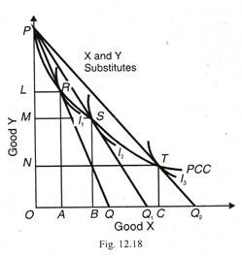
If we regard PQ₂, as the original budget line, a two time rise in the price of X will lead to the shifting of the budget line to PQ₁, and PQ₂. Each of the budget lines fanning out from P is a tangent to an indifference curve I₁, I₂, and I₃ at R, S and T respectively. The curve PCC connecting the locus of these equilibrium points is called the price- consumption curve. The price-consumption curve indicates the price effect of a change in the price of X on the consumer’s purchases of the two goods X and Y, given his income, tastes, preferences and the price of good Y.

